**Assignment 2:Twitter Service**

**Team Invincibles:**

**Priyanka Turumalla**

**Rishabh Gupta**

**Poojan Shah**

**Sri Akhil Thaneti**

**Sai Sanketh Ravva**

**Git Repo :**

[**https://github.com/TPriyanka22/CMPE272-Twitter-Invincibles**](https://github.com/TPriyanka22/CMPE272-Twitter-Invincibles)

**Steps for the UI interaction**

1. **Prerequisites to start with the project is to have a developer Twitter account with elevated access to make use of the Twitter API and get the necessary access tokens to avoid CORS errors.**
2. **Please install NodeJS and NPM to run the project. Vscode was used as an IDE to code.**

**Steps to launch the project:**

* 1. **Npm install (to install all packages)**
  2. **Npm test (to run the tests)**

1. **The front end of our code runs on the local port - 3000 and the backend server on 8080.**

**Below is the screenshot of the Twitter_Service_UI which includes an input textbox to enter the text and two buttons to**

**Search and Post the tweet.**

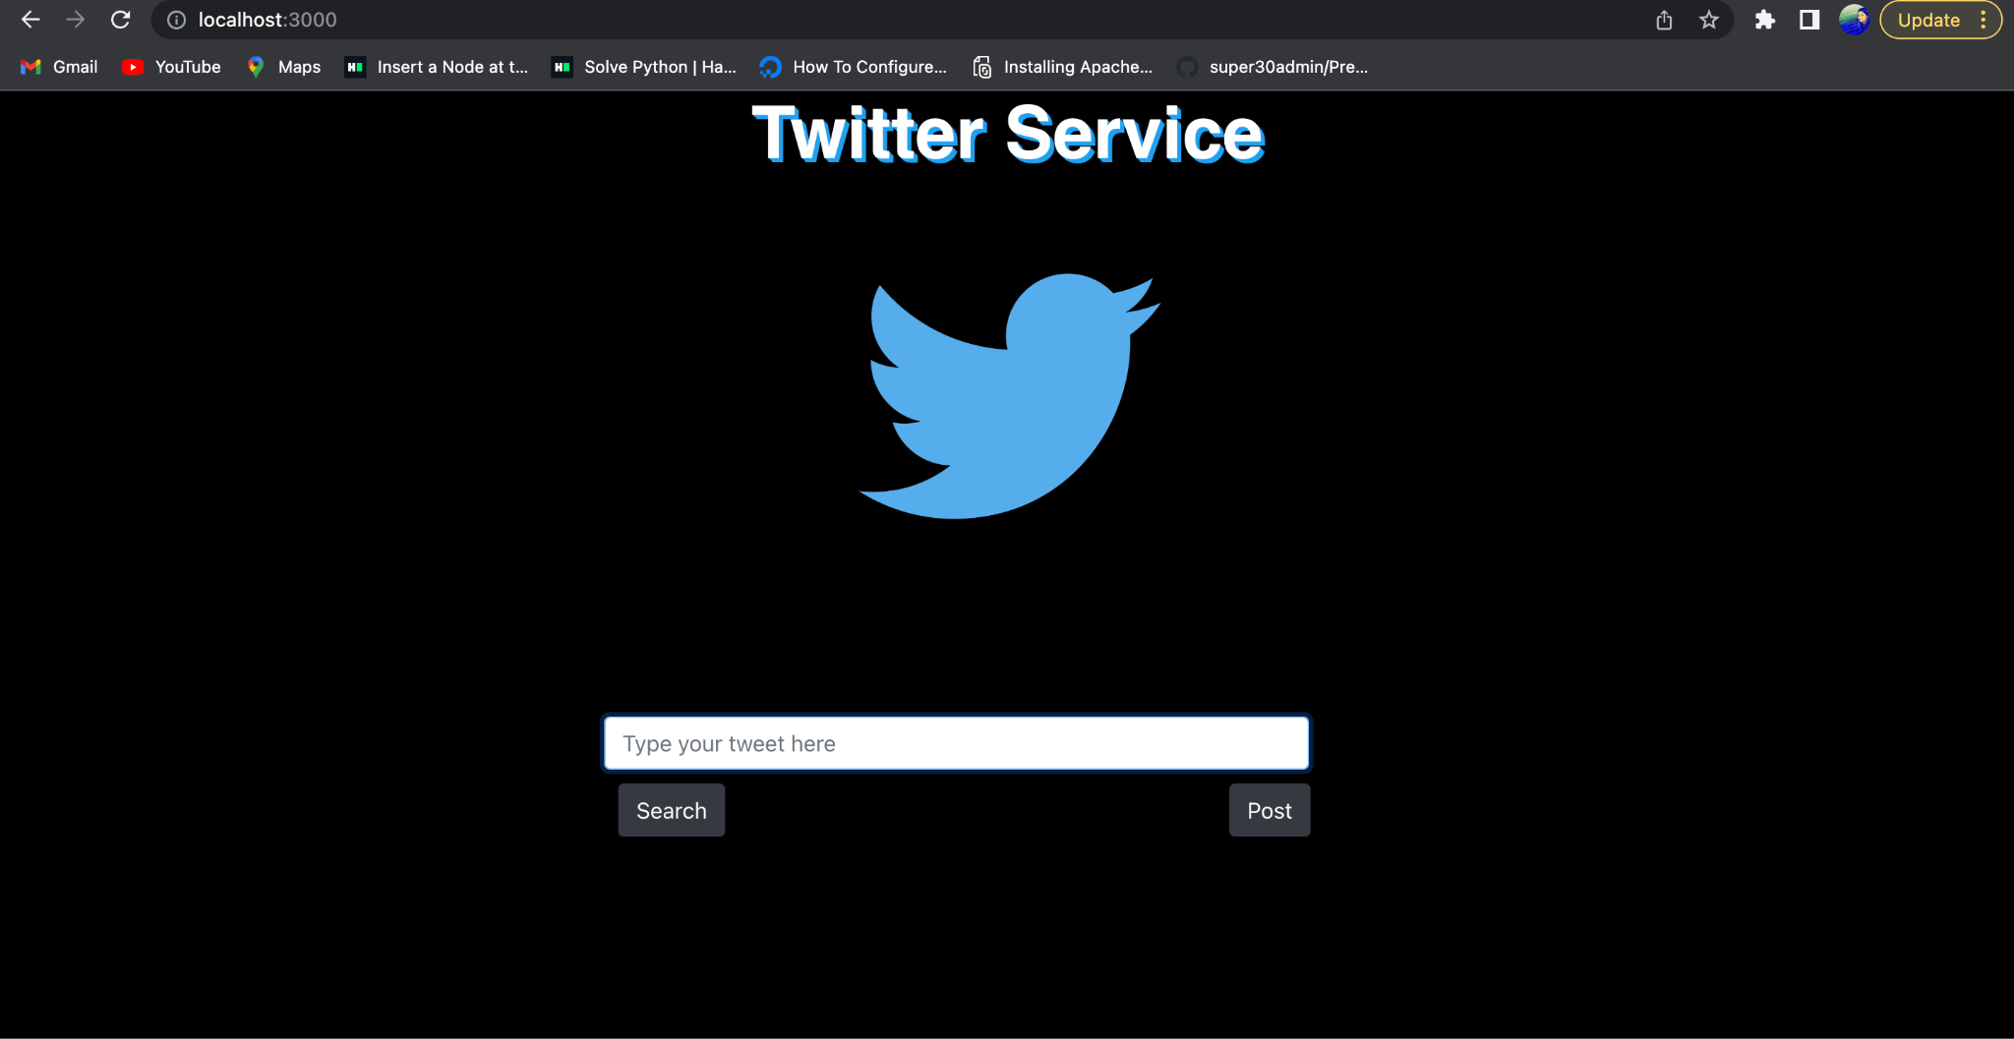

1. **We have to run the ‘npm start’ command from the frontend and backend to start the server on the respective ports.**

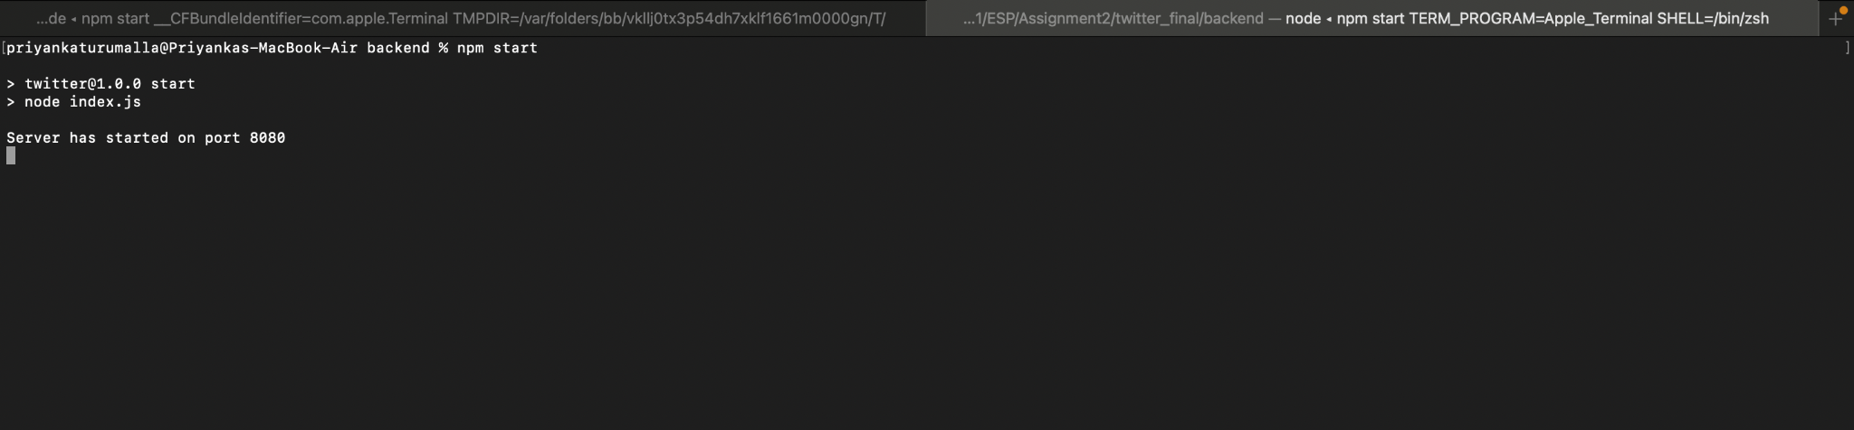

**To check the response to the request, we used Postman as shown below:**

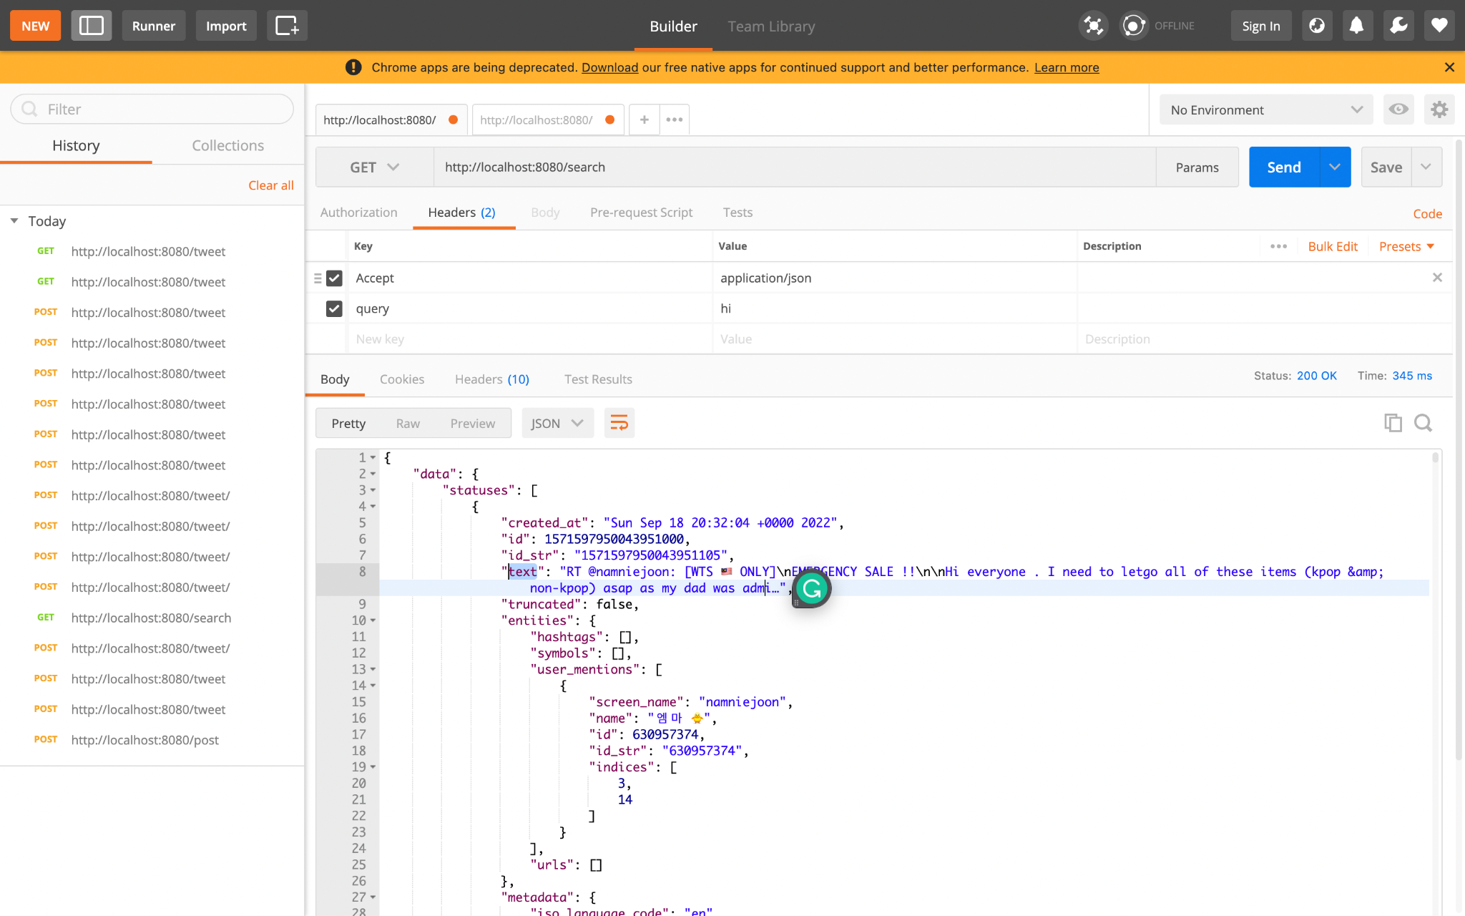

1. **To search the tweet in the Twitter environment, enter the text in the input box and click on the search button**

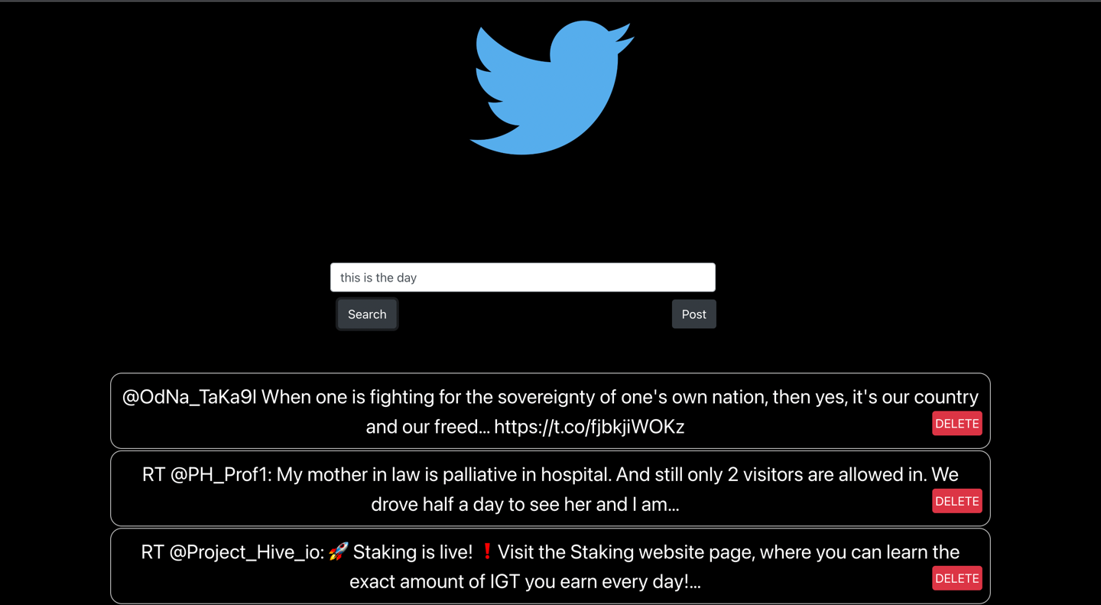

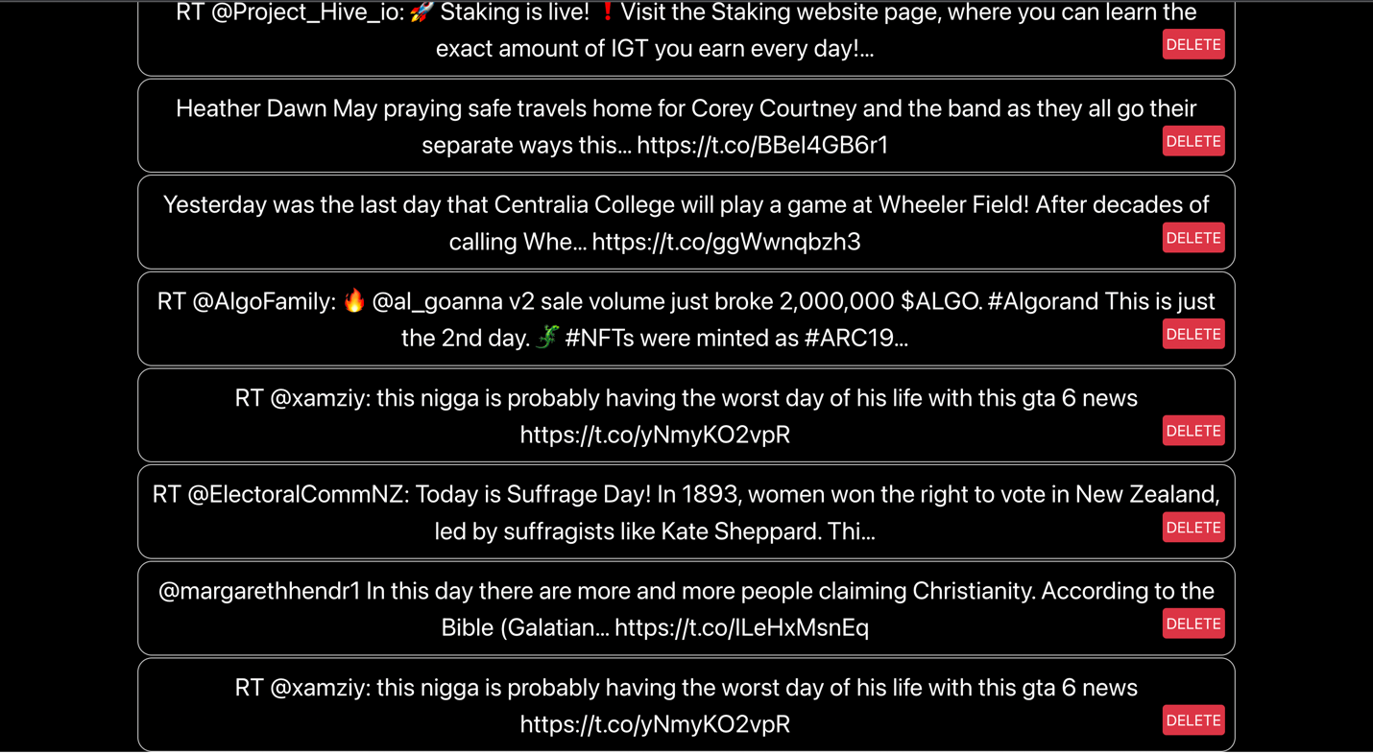

**as shown in the above screenshot: 10 records have been fetched as the limit is set to count 10 while fetching the records.**

1. **To post the tweet, enter the text in the input box and click post. A toast message would be displayed as - “Your tweet is posted!”**

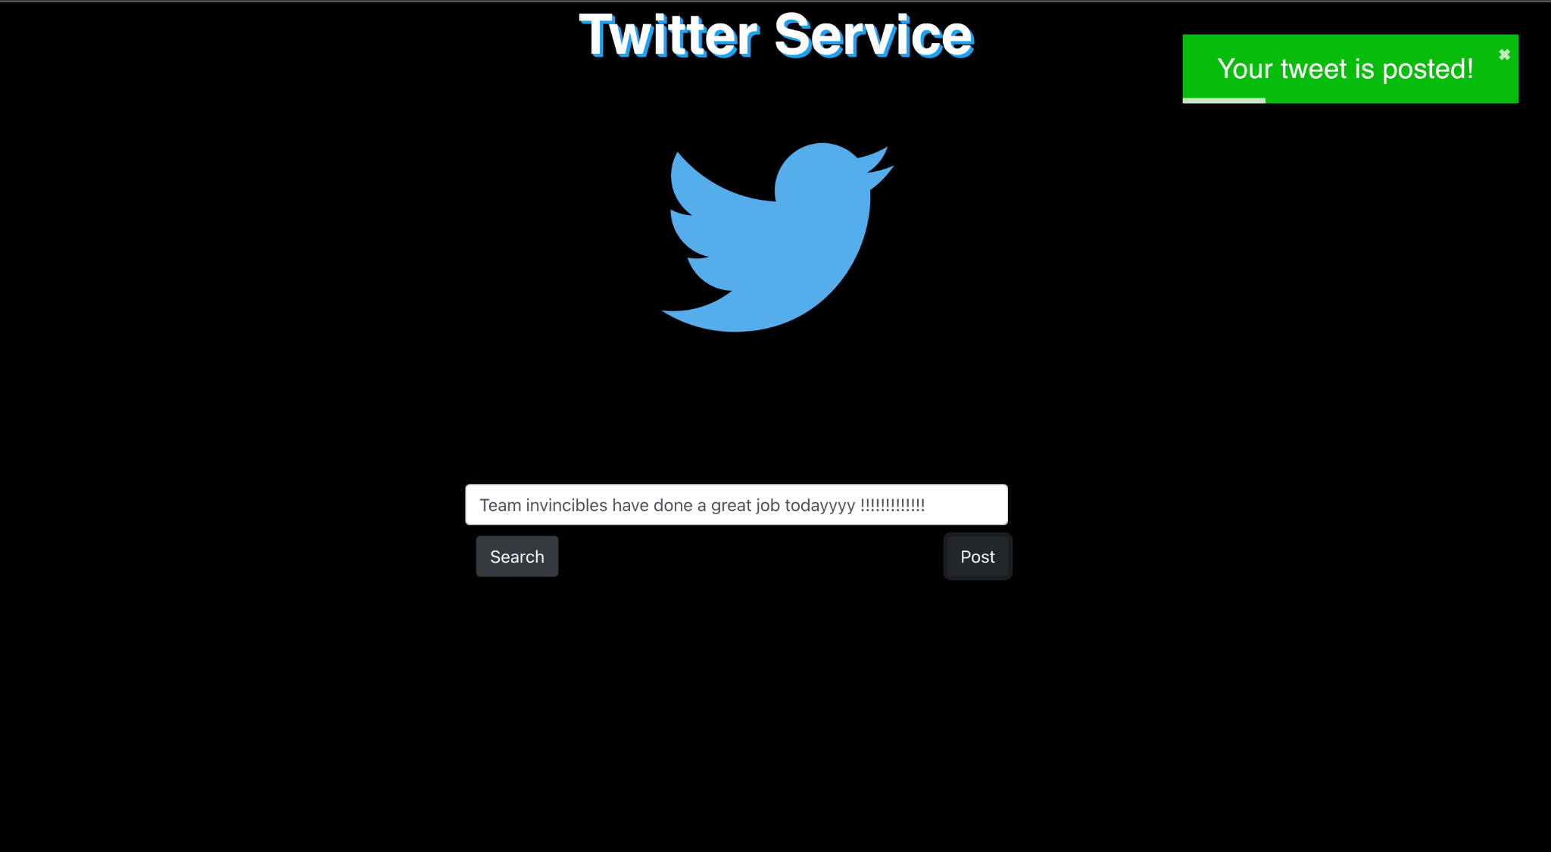

**and we can search the text again to get the record as shown in the next screenshot.**

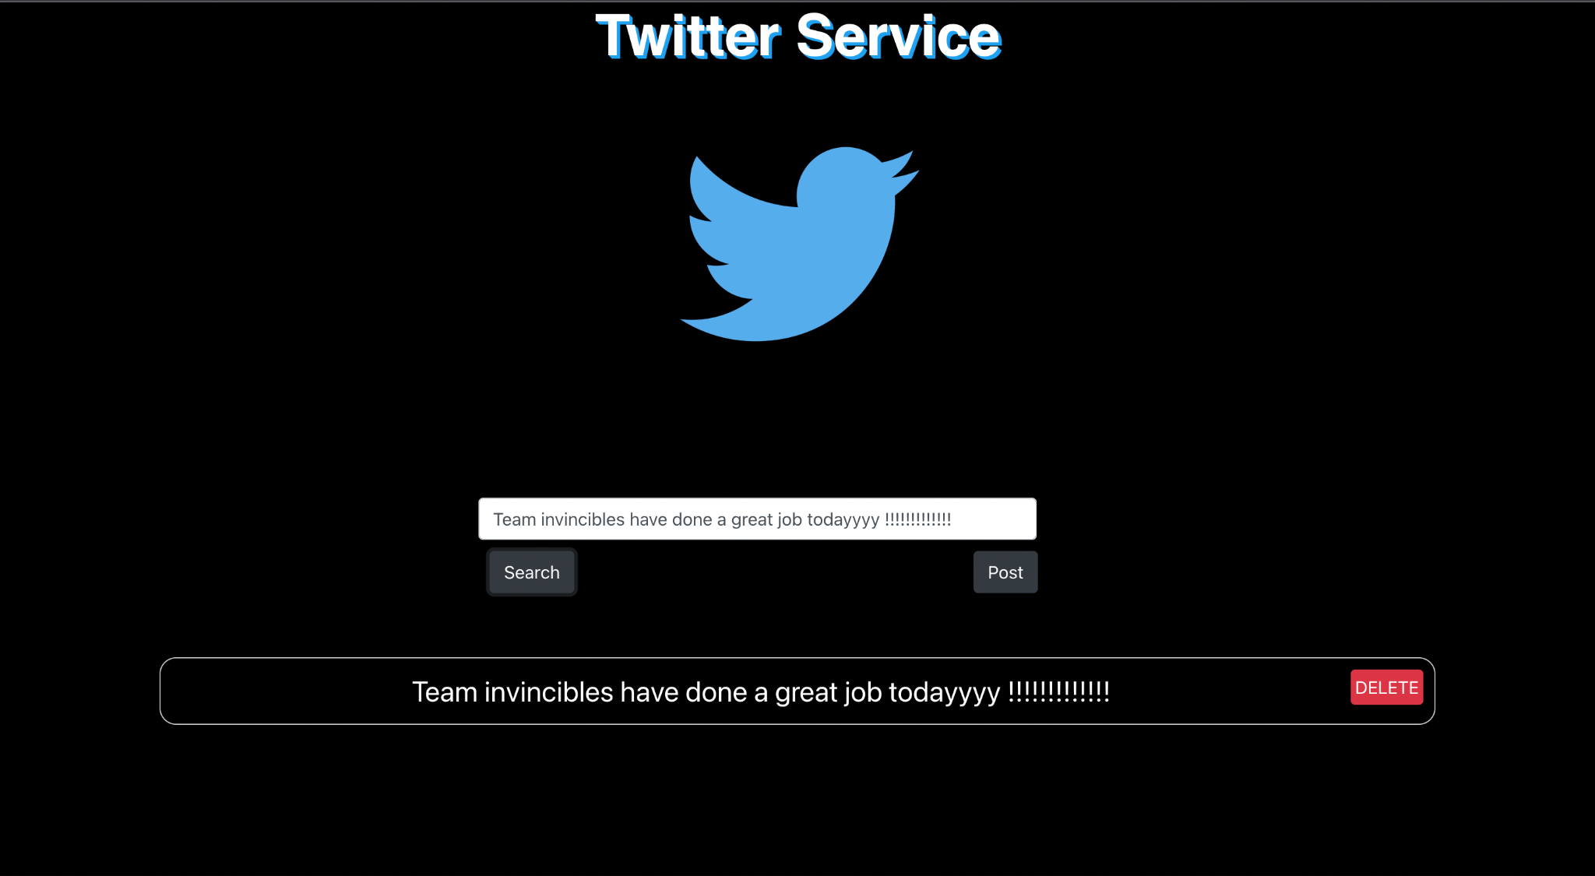

**7. Similarly, to delete the tweet, search for the tweet and click on delete button and toast message would appear as ‘Your tweet is deleted!’. We can make sure of the same by searching the query again as shown in the below screenshot.**

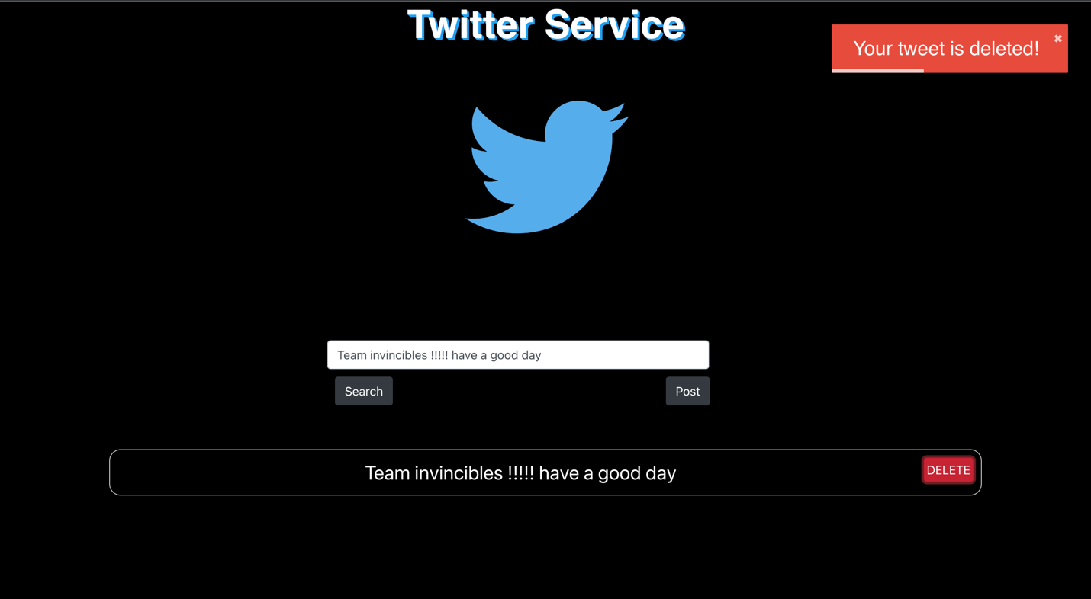

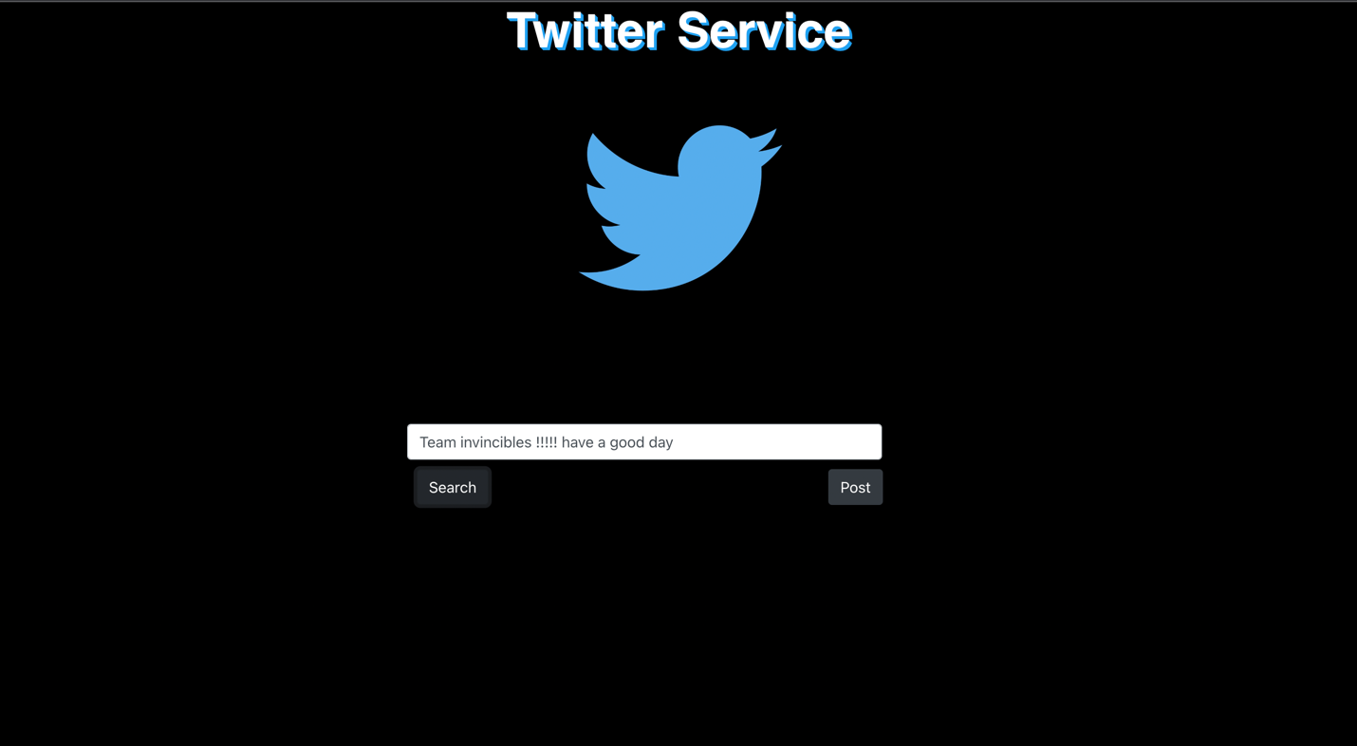

**8. Here is the catch, we cannot delete tweets posted by other users. We have handled that scenario as well as shown in the below screenshot.**

**Here, we entered text as ‘tweet’ and searched then tried to delete the first record, thus the toast message appears as follows:**

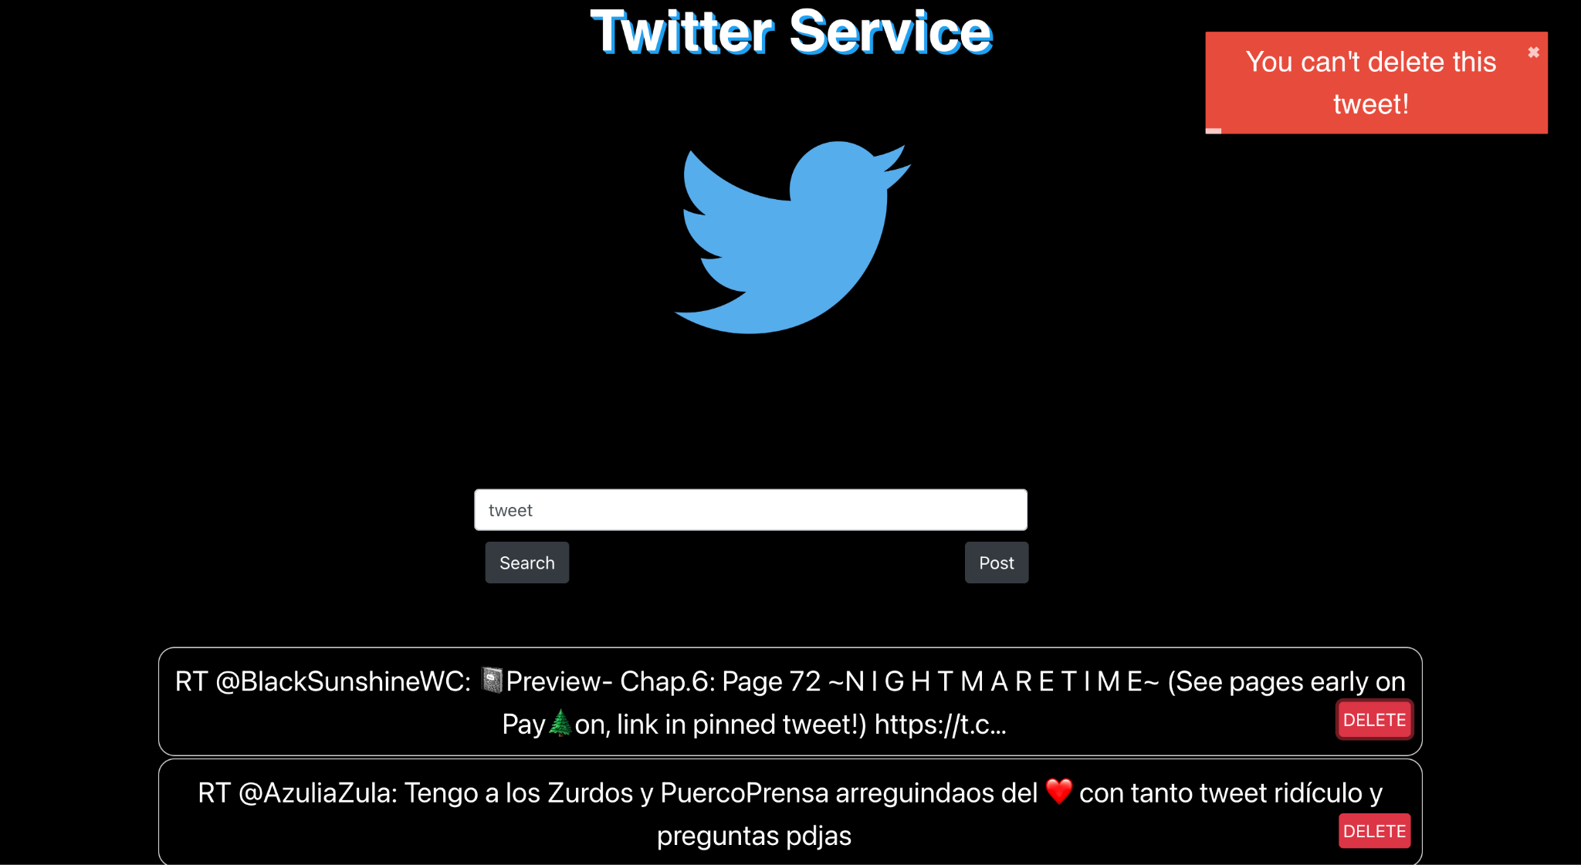

**9. We have performed Unit tests as well, Please find the attached screenshot.**

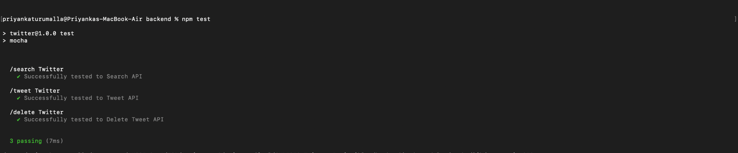

**References:** [**https://daily.dev/blog/a-guide-to-writing-clean-api-calls-using-axios**](https://daily.dev/blog/a-guide-to-writing-clean-api-calls-using-axios)

[**https://www.knowledgehut.com/blog/web-development/create-index-node-js**](https://www.knowledgehut.com/blog/web-development/create-index-node-js)

[**https://codelog.network/2021/12/08/simple-twitter-bot-using-nodejs-and-twit/**](https://codelog.network/2021/12/08/simple-twitter-bot-using-nodejs-and-twit/)